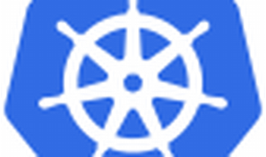

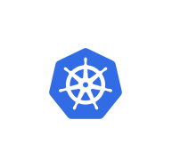

Explore

Certainly! Let’s dive into Kubernetes containers and provide you with some free learning resources.

**Kubernetes Containers in One Sentence:** A **container** in Kubernetes is a self-contained package that includes an application along with its dependencies (such as code, runtime, and system libraries), allowing it to run consistently across different environments.

Here are **five free reference links** where you can learn more about Kubernetes and containers:

1. [**Kubernetes Basics**](https://kubernetes.io/docs/tutorials/): This interactive tutorial helps you understand the Kubernetes system and explore basic features.
2. **Introduction to Kubernetes (edX)**: A comprehensive course covering Kubernetes fundamentals.
3. [**Civo Academy**](https://www.civo.com/academy): Over 50 video guides and tutorials to help you navigate Kubernetes, from understanding containers to launching and scaling clusters.
4. [**Geekflare’s Kubernetes Tutorials**](https://geekflare.com/learn-kubernetes/): Offers hands-on tutorials for beginners and more advanced learners.
5. **KubeAcademy by VMware**: A collection of video lessons to get you started with Kubernetes.

Feel free to explore these resources and enhance your understanding of Kubernetes and container orchestration! 🚀🌟